**Software Delivery Schedule:**

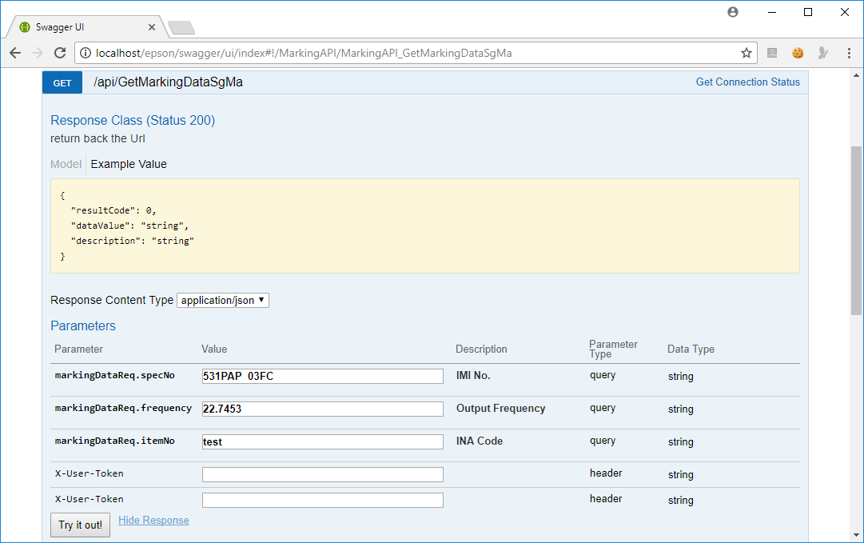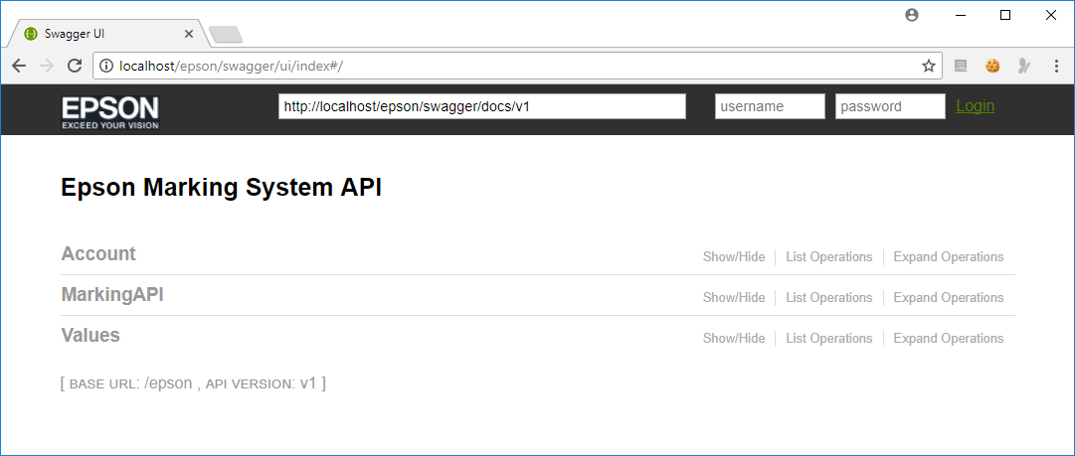

**The Marking Restful Web API (Web Service) has been delivered to Epson before end of January 2018. As highlighted, PE are required to validate the marking data produce by the Web Service before the new marking software can be install to production.**

**In Progress**

Test Run TOM

Install new marking system to Laser Marking machine

P.O. Received

**Marking Web Service Validation Complete**

1st Week

2nd Week

Mar 2018

**Marking Web Service**

1st Week

2nd Week

3rd Week

4th Week

Feb 2018

Jan 2018

3rd Week

4th Week